Integrating the Healthcare Enterprise



IHE Patient Care Coordination (PCC)

Technical Framework Supplement

Labor and Delivery Record
(LDR)

Draft for Public Comment
May XX, 2010

Date: <May XX, 20XX>
Author: <Author Name>

Email: <ihe@himss.org>
Foreword
This page is standard language for all IHE supplements. The Introduction section following will list all other IHE documents that are modified by this supplement. This document is a supplement to the IHE Patient Care Coordination Technical Framework 4.0. The technical framework can be found at http://www.ihe.net/Technical_Framework/index.cfm#pcc.
This and all IHE supplements are written as changes to a base document. The base document is normally one or more IHE Final Text documents. Supplements tell a technical editor and the reader how to modify the final text (additions, deletions, changes in wording). In order to understand this supplement, the reader needs to read and understand all of the base documents that are modified by this supplement.
In this supplement you will see “boxed” instructions similar to the following:
Replace Section X.X by the following:
These “boxed” instructions are for the author to indicate to the Volume Editor how to integrate the relevant section(s) into the overall Technical Framework.
This format means the reader has to integrate the base documents and the supplement. When the material in the supplement is considered ready for incorporation into the final text of the Technical Framework, the IHE committees will update the technical framework documents with the final text. Supplements are written in this format to avoid duplication material. This means that two IHE documents (one possibly final text, and the other a supplement) should not contain contradictory material.
Text in this document is not considered final for the Technical Framework. It becomes Final Text only after the IHE PCC Technical Committee ballots the supplement (after testing) and agrees that the material is ready for integration with the existing Technical Framework documents.
It is submitted for Trial Implementation starting August XX, 20XX.
Comments on this supplement may be submitted http://forums.rsna.org:
- Select the “IHE” forum
- Select Patient Care Coordination Technical Framework
- Select 2009-2010 Supplements for Public Comment
- Select Immunization Care Plan

Please use the Public Comment Template provided there when starting your New Thread.
Details about IHE may be found at: www.ihe.net
Details about the IHE Patient Care Coordination may be found at: http://www.ihe.net/Domains/index.cfm
Details about the structure of IHE Technical Frameworks and Supplements may be found at: http://www.ihe.net/About/process.cfm and http://www.ihe.net/profiles/index.cfm

Introduction
This supplement is written for Trial Implementation. It is written as changes to the documents listed below. The reader should have already read and understood these documents:
- PCC Technical Framework Volume 1, Revision 4.0
- PCC Technical Framework Volume 2, Revision 4.0
This supplement also references other documents. The reader should have already read and understood these documents:
- IT Infrastructure Technical Framework Volume 1, Revision 5.0
- IT Infrastructure Technical Framework Volume 2, Revision 5.0
- The Patient Identifier Cross-Reference (PIX) and Patient Demographic Query (PDQ) HL7 v3 Supplement to the IT Infrastructure Technical Framework.
- HL7 and other standards documents referenced in Volume 1 and Volume 2
Dilbert 2.0: 20 Years of Dilbert by Scott Adams, ISBN-10: 0740777351, ISBN-13: 978-0740777356
This supplement describes three content profiles that will be used as part of the Labor and Delivery Record Content profile. This supplement includes material that describes the motivation for the Labor and Delivery profile, and that in turn provides motivation for the three content profiles. The definition and requirements of the Labor and Delivery profile are left for the next documentation cycle.

Open Issues and Questions
- There can be health information systems within the same healthcare facility that do not communicate with the LDR. These systems might include nursery, the NICU or even Postpartum. Even if all the systems creating the information captured in the LDR are interoperable, the mother or the newborn record might interact with yet another system, resulting in a different type of information, for example anesthesiology information or data captured in the operating room (OR). In such environments the data will be captured on paper. A method will have to be designed so that the information is not lost, either through manual entry or scanning the documents. This will be duplicating the documentation of data.
- If a walk-in patient is admitted to a facility, and she does not have an APS or an APR, then this information will have to be entered again, provided it is not an emergency case. This information will become part of the LDR. There will be some duplication between the information in APR and LDR. Until a complete data element analysis is done, and cross-referencing performed we cannot say to what extent this information will be duplicated.
- How will data for each individual infant in the case of a multiple birth be differentiated?

Closed Issues
- The Newborn Discharge Summary and the Maternal Post-Partum Visit Summary content profiles are not part of this year’s work. This is deemed to be out of scope and considered as a future work item. Once the newborn has left the birth room, the newborn data collected becomes out of scope. If the NICU team becomes involved in the birth room, this information becomes part of the newborn’s record independent of where the newborn will be transferred. If there are complications (NICU involved), the complications will be recorded (immediate resuscitation and stabilization in the birth room only), and it will be part of the Labor and Delivery Summary, becoming part of the mother’s record.
- The Document Metadata Subscription (DSUB) profile being written this year will not be considered to replace the Notification of Document Availability (NAV) profile until it has been tested at the Connectathon.
- If there are any relevant laboratory results, images, or fetal heart rate tracings, they should be captured in the LDR. However, this is not a profile dependency, but a recommendation.
- The newborn’s identifier will be filed against the mother’s file.

TABLE OF CONTENTS

Volume 1 – Profiles 5
1.1.5 Copyright Permissions 5
2.5 Dependencies of the PCC Integration Profiles 5
2.7 History of Annual Changes 5
X <Profile Name Content/Integration> Profile 5
X.1 Purpose and Scope 5
X.2 Use Cases 5
X.3 Actors/Transactions 5
X.4 Options 7
X.5 Groupings 8
X.6 Security Considerations 8
X.7 Requirements of Actors 9
X.8 Content Modules 9
X.9 Process Flow 9
<Appendix A> Actor Summary Definitions 10
<Appendix B> Transaction Summary Definitions 10
Glossary 11
Volume 2 – Transactions and Content Modules 11
3.0 IHE Transactions 11
3.Y <Transaction Name> 11
3.Y.1 Scope 11
3.Y.2 Use Case Roles 11
3.Y.3 Referenced Standard 12
3.Y.4 Interaction Diagram 12
3.Y.4.1 <Message_1 Name> 12
3.Y.4.1.1 Trigger Events 12
3.Y.4.1.2 Message Semantics 12
3.Y.4.1.3 Expected Actions 12
3.Y.4.2 <Message_2 Name> 13
3.Y.4.2.1 Trigger Events 13
3.Y.4.2.2 Message Semantics 13
3.Y.4.2.3 Expected Actions 13
3.Y.5 Security Considerations 13
3.Y.5.1 Security Audit Considerations 13
3.Y.5.1.(z) Actor Specific Security Considerations 13
5.0 Namespaces and Vocabularies 13
5.1 IHE Format Codes 14
6.0 PCC Content Modules 14
6.2 Folder Content Modules 14
6.2.Y <Folder Specification Name> 14
6.3 HL7 Version 3.0 Content Modules 14
6.3.1 CDA Document Content Modules 14
6.3.1.A <Document Content Module Specification Name> 14
6.3.2 CDA Header Content Modules 15
6.3.2.B <Header Content Module Specification Name> 15
6.3.3 CDA Section Content Modules 15
6.3.3.C <Section Content Module Specification Name> 15
6.3.4 CDA Entry Content Modules 15
6.3.4.D <Entry Content Module Specification Name> 15
6.5 PCC Value Sets 15
6.5.A <Value Set Name> 15
<Appendix letter> Appendix_Name 15

Volume 1 – Profiles
Add the following to section 1.1.5
1.1.5 Copyright Permissions

Add the following to section 2.5
2.5 Dependencies of the PCC Integration Profiles

Content Profile | Depends on | Dependency Type | Purpose
LDHP, LDS, MDS | Audit Trail and Node Authentication (ATNA) | Each Content Creator and Content Consumer actor shall be grouped with the ATNA Secured Node Actor | Required to manage audit trail of exported PHI, node authentication, and transport encryption.
LDHP, LDS, MDS | Consistent Time (CT) | Each Content Creator and Content Consumer actor shall be grouped with the Time Client Actor. | Required to manage and resolve conflicts in multiple updates.

Add the following to section 2.7
2.7 History of Annual Changes
- Added three content profiles which provide the means to capture standardized information about the labor, delivery and postpartum care administered to the mother and the newborn. These content profiles are: Labor and Delivery Admission Health and Physical, Labor and Delivery Summary, and Maternal Discharge Summary.

Add Section X
X Labor and Delivery Record Content Profile
<200 words or less describing this profile – this is the Profile Abstract that goes in the Executive Summary document. >
The Labor and Delivery Record (LDR) is a continuation of the Antepartum Record (APR).
The LDR provides comprehensive information regarding the course of labor and delivery to healthcare providers caring for both the mother and the newborn in the postpartum period. For example, in cases such as chorioamnionitis or birth trauma, if the postpartum nurse or the attending obstetrician were not present at the birth, the LDR would be crucial for risk identification and appropriate inpatient postpartum care. The pediatrician uses the information present in the LDR to develop the infant’s plan of care. The outpatient care is out of scope for this profile, as well as the newborn’s discharge summary from the birthing facility. In some settings, public health officials are interested in the labor, delivery and inpatient postpartum information as to better monitor the mother and child’s health, and develop quality improvement processes if necessary. Certain data present in the LDR is monitored anonymously as to conduct studies about population health. The public health aspect is out of scope for this profile as it is addressed in the Quality, Research and Public Health (QRPH) domain.

The information collected during labor, delivery and the immediate postpartum period is very important to follow-up care for both mother and infant whether the follow-up care is provided in an inpatient or outpatient facility. A physician's recommendation for a follow-up hematocrit test or evaluation of the incision in the office may be noted in the Labor and Delivery Record or in the Maternal Discharge Summary. These documents must be available in both inpatient and outpatient settings. Pertinent maternal information includes, but is not limited to: delivery type; labor type; anesthesia type; labor, delivery and postpartum complications; and specific maternal information such as medications, laboratory test results, allergies and plans for contraception. Pertinent neonatal information includes, but is not limited to: delivery method, gender, birth time, birth weight, gestational age at delivery, APGAR scores and medications received in the delivery room including immunizations. All this information can be obtained in different parts of the Labor and Delivery Record (LDR) such as the Labor and Delivery Summary and the Maternal Discharge Summary.

X.1 Purpose and Scope
<This section focuses on purpose and scope by starting with a clear statement of the problem being addressed. It expands on this with statements of specific inclusions and exclusions of scope, value statements to represent why this problem is being solved and diagrams (if applicable) to represent the problem being addressed (and not the solution to the problem).>
The information found in the LDR is important for continuation of care for the mother and the newborn, in both inpatient and outpatient settings, and should be available to all healthcare providers. Prior to discharge from the birthing facility, the mother receives a comprehensive assessment which provides the follow-up health care provider with the details of the labor and delivery, as well as a “snapshot” of the mother’s condition at discharge. The newborn’s status immediately following birth, while the newborn is still in the delivery room is also captured thus if any complications arise and the newborn is transferred to a specialized unit, this information is available.
The typical workflow resulting in the collection of this information in a laboring patient is as follows:
- Maternal demographic information is recorded or verified when the mother arrives at the birthing facility if the situation permits (i.e. the delivery is not immediate).
- An Admission History and Physical Assessment is performed (or updated) if the situation permits (i.e. the delivery is not immediate).
- Labor information is recorded.
- The mother delivers.
- A Labor and Delivery Summary (LDS) is produced.
- Information is captured at the time of birth about the infant's delivery course and becomes part of the mother’s record.
- Maternal post-partum information is recorded.
- The mother leaves the birthing facility and a Maternal Discharge Summary (MDS) is produced.
- The information about the mother and child can be shared seamlessly between the stakeholders.

The information collected varies according to the type of birthing facilities, their birthing practices and location, and also depends on the characteristics of mothers and newborns.
The stakeholders are: attending physicians, resident physicians, medical students and staff, obstetrician-gynecologists, family physicians, covering physicians, nurse midwives, physicians’ assistants, nurse practitioners, pediatricians, healthcare administrators, social workers, , other medical specialists, researchers, patient safety and quality officers, billing specialists, pharmacists, laboratory personnel, and public health officials.
The information is uniform in terms of structure and content and the resulting documents can be shared between all the stakeholders. Also, this information may also be incorporated into a patient's personal health record (PHR). The LDR is kept at least until the age of majority, and the information could be collected by Social Services, as well as Public Health officials for epidemiological studies.

This year’s scope will be limited to the Labor and Delivery information, the information about the infant in the birth room, and the Maternal Discharge Summary. The resulting content profiles present in the LDR are:
- The Labor and Delivery Admission History and Physical (LDHP) content profile which can point to the Antepartum Admission History and Physical content profile from the Antepartum Record. If there is no Antepartum Record a new document The Labor and Delivery Admission History and Physical will be created.
- Labor and Delivery Summary (LDS) content profile containing a summary of the labor and delivery course and the Newborn’s Birth Summary while in the birth room.
- Maternal Discharge Summary (MDS) content profile representing the mother’s postpartum course up until her discharge from the birthing facility and the newborn’s status).

The LDR is not defined as an actual profile. Use the LDR information as background. To implement against this supplement, you will implement one or more of the content profiles.

X.2 Use Cases

X.3 Actors/Transactions

Note: This is a note

X.4 Options

X.5 Groupings

X.6 Security Considerations

X.7 Requirements of Actors

X.8 Content Modules

X.9 Process Flow

X.9.1 Current Situation
A 36+ week pregnant multiparous woman is carrying a fetus with a small right lung mass. She was told this should not present a significant problem after birth, but the baby should be evaluated by the pediatrician. She has recently moved to the area and is transferring her care to a new obstetrician. She presents for her first prenatal care visit with her obstetrician on Friday. However, her paper-based antenatal records from her previous physician’s office have not been sent. Her physician’s office has already closed for the weekend and cannot be contacted. She mentions that the fetus was diagnosed with a lung tumor, but does not remember the exact diagnosis. The new obstetrician’s office uses an EHR not connected to any health information exchange (HIE), and all documents related to the patient’s pregnancy are accessible only from that system.
The woman had a Group B Streptococcus culture performed just prior to moving, which was positive, but the patient did not receive the results. She is blood type O negative. She is hepatitis B surface antigen negative although she is not aware of this.
On Saturday, she goes into active labor and presents to Labor and Delivery at 37 weeks gestation. Her prenatal records are not available in Labor and Delivery; therefore her prenatal laboratory results are not available and are redrawn. The patient has an uneventful 3 hour labor course and is delivered by the on-call obstetrician. The infant has an APGAR score of 5 at 1 minute, and a score of 8 at 5 minutes.
The covering obstetrician is unaware of her Group B Streptococcus result and she did not receive antibiotics in labor. She does mention that the baby has a lung mass to the obstetrician who then alerts the pediatrician. As her hepatitis B status is unknown, the baby ends up getting hepatitis immune globulin unnecessarily. Initially, the baby does well, but several hours after birth, begins to exhibit evidence of respiratory distress. A chest x-ray shows finding of a possible right lung mass. Believing the respiratory distress is due to a lung lesion, and the unavailability of a Special Care Nursery service or a pediatric surgeon at the birthing center, the infant is transported to the nearest NICU across town five miles away.
The NICU care providers are also unaware of the positive Group B Streptococcus. Antibiotic treatment is not begun until the infant begins showing signs of sepsis and the baby does poorly. The mother does tell them she is Rh negative, but they cannot immediately verify it.

Figure X.9-1. Current Situation Process Flow in Labor and Delivery Record Profile
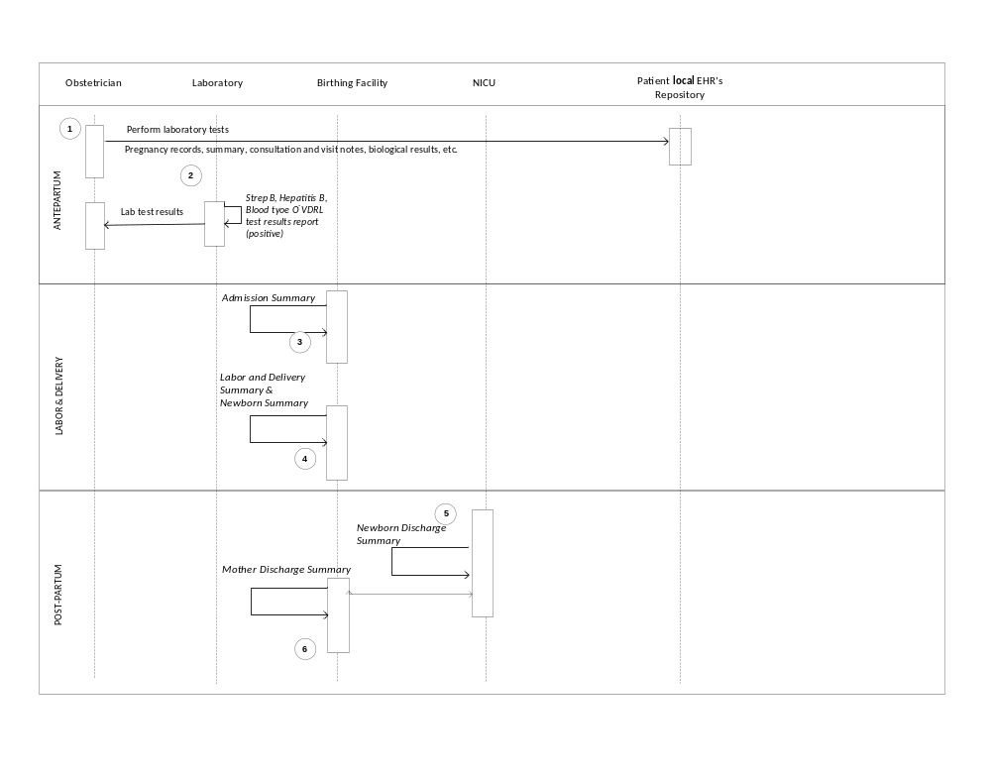
X.9.2 Desired Situation

A36+ week multiparous pregnant woman moves to the area and establishes care with a new obstetrician. Both offices utilize an EHR that participates with the HIE. All documents related to the patient’s pregnancy are accessible due to the implementation of various clinically interoperable profiles. These are based on national specifications which are in turn based on IHE profiles. The woman had a Group B Streptococcus test performed by her previous obstetrician just before moving. The patient’s prenatal record and laboratory results, including her positive results of the Group B streptococcus culture, prenatal ultrasounds which show that the small lung mass is a small congenital cystic adenomatoid malformation, which has regressed over the course of the pregnancy and deemed unlikely to cause any respiratory compromise at birth, are uploaded into the new obstetricians EHR and available at her first appointment with her new doctor (2). Her doctor reviews the lab results and informs the patient she will need antibiotics during labor to prevent transmitting Group B Streptococcus to her baby.
On Saturday, she has a rapid onset of labor at 37 weeks gestation, rushing to the local birthing center and rapidly delivers an infant 3 hours after arrival, with an APGAR score of 5 at 1 minute, and a score of 8 at 5 minutes. The mother, aware of the positive Group B Streptococcus result, tells the nurse of her need for antibiotics. The nurse verifies the culture results and administers penicillin per protocol. As the patient’s negative hepatitis B surface status is known, the baby is not given hepatitis B immune globulin. Her Rh-negative status is also known (3, 4).
The neonate shows signs of respiratory distress. As the baby delivered less than 3 hours after receiving antibiotics for Group B Streptococcus prophylaxis, there is early suspicion of early onset Group B Streptococcal pneumonia and/ or sepsis. In consultation with the on call neonatologist at the regional NICU, the pediatrician initiates a sepsis work up and begins intravenous antibiotics and arranges for transport to the regional NICU. Because of the unavailability of Special Care Nursery services at the birthing center, the infant is transported to the nearest NICU five miles away. Antibiotics are continued at the NICU.
When the mother's obstetrician calls the NICU the next morning, she is extremely happy to hear that evaluation and treatment were initiated immediately and the baby is doing fine.
The mother and the newborn are discharged and a maternal discharge summary is created (6).
The potential for extended hospitalization or further complications due to inaccessible information is eliminated because information is shared within the HIE.

Figure X.9-2. Desired Situation Process Flow in Labor and Delivery Record Profile

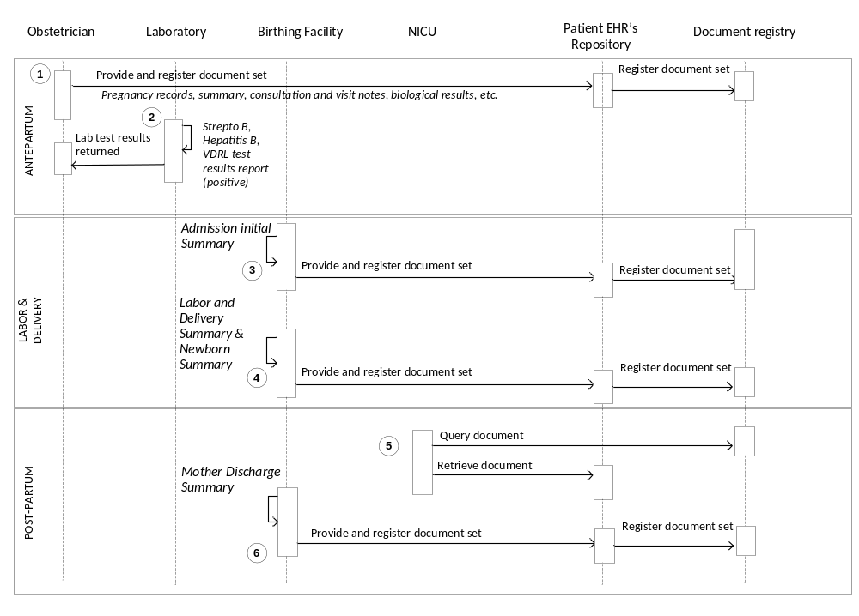

<Appendix A> Actor Summary Definitions
<add any actor definitions for new actors defined specifically for this profile>

<Appendix B> Transaction Summary Definitions
<add any transaction definitions for new transactions defined specifically for this profile>

Glossary
Add the following terms to the Glossary:

Anesthesia
Loss of the ability to feel pain, caused by administration of a drug or other medical intervention.

Antepartum
Of or occurring in the period before childbirth

Antibody screen
A blood test to detect antibodies against red blood cell antigens.

Apgar scores
A score that assesses the general physical condition of a newborn infant by assigning a value of 0, 1, or 2 to each of five criteria: heart rate, respiratory effort, muscle tone, skin color, and response to stimuli. The five scores are added together, with a perfect score being 10. Apgar scores are usually evaluated at one minute and five minutes after birth. If the 5 minute Apgar score is < 7 then additional Apgar scores should be taken every 5 min up to 20 min.
The score is based on the following criteria:
Appearance: Color – 0 for blue, 1 for body pink, extremities blue, 2 for pink. Pulse: Heart rate – 0 for none, 1 for <100/min, 2 for > 100/min.
Grimace: Reflex – 0 for none, 1 for grimace, 2 for cough/sneeze.
Activity: Muscle tone – 0 for limp, 1 for some flexion, 2 for full flexion. Respiratory: Effort – 0 for absent, 1 for weak or irregular, 2 for strong crying.

APS
Antepartum Summary content profile.

APR
Antepartum Record content profile.

ATNA
Audit Trail and Node Authentication. IT Infrastructure profile, described in ITI TF-1:9, and published in version 6.0 of the ITI Technical Framework.

Blood type
Test to determine blood group, i.e. A, B, AB or O

CT
Consistent Time. IT Infrastructure profile, described in ITI TF-1:7, and published in version 6.0 of the ITI Technical Framework.

Contraception (birth control)
A process that prevents pregnancy by interfering with the normal process of ovulation, fertilization, and implantation. There are different kinds of birth control that act at different points in the process.

Contractions
Obstetric volleys of tightening and shortening of the myometrium (uterine muscle), which occur during labor, cause dilatation and thinning of the cervix and aid in the descent of the infant in the birth canal.

Delivery
Expulsion or extraction of the infant, placenta and membranes at birth.

D(Rh) Antibody Screen
A blood screening test for presence of IgG antibodies to the Rh D antigen on red blood cells.

D (Rh) Sensitized
Rh negative mother is sensitized to the Rh D antigen. A sensitized mother produces IgG anti-D (antibody) that crosses the placenta and coats D-positive fetal red cells which are then destroyed in the fetal spleen.

DSG
Document Digital Signature. IT Infrastructure profile, described in ITI TF-3:4, and published as a supplement for trial implementation.

DSUB
Document Metadata Subscription. IT Infrastructure profile, described in ITI TF-1:26, and published as a supplement for trial implementation.

Erythrocytes
A red blood cell that transports oxygen through the body.

Gestation
The period of development in the uterus from conception until birth; pregnancy.

Hematocrit
The volume percentage of erythrocytes in whole blood.

Hepatitis B
A serious liver infection caused by the hepatitis B virus (HBV). Pregnant women who are infected with hepatitis B can transmit the virus to their newborns during pregnancy or delivery.

Incision
A cut into a body tissue or organ, especially one made during surgery or the scar resulting from such a cut.

Inpatient
A patient who is admitted to a hospital or clinic for treatment that requires at least one overnight stay.

Labor
The function of the female by which the infant is expelled through the vagina to the outside world: the first stage begins with onset of regular uterine contractions and ends when the os is completely dilated and flush with the vagina; the second extends from the end of the first stage until the expulsion of the infant is completed; the third extends from expulsion of the infant until the placenta and membranes are expelled; the fourth denotes the hour or two after delivery, when uterine tone is established.

LDHP
Labor and Delivery Admission History and Physical content profile.

LDR
Labor and Delivery Record content profile.

LDS
Labor and Delivery Summary content profile.

MDS
Maternal Discharge Summary content profile.

Multiparous
Having given birth to more than one offspring.

Multiple Gestation or Multiple Birth
A multiple gestation or multiple birth occurs when more than one fetus is carried to term in a single pregnancy.

Myometrium
The muscular wall of the uterus.

NAV
Notification of Document Availability. IT Infrastructure profile, described in ITI TF-1:12, and published as a supplement for trial implementation.

Neonatal
Pertaining to a newborn child < 28 days of age or 44 weeks postconceptual age.

NICU
Neonatal intensive-care unit. Unit of a hospital specializing in the care of ill or premature newborn infants.

Obstetrician
A physician whose practice of medicine focuses on the care of women during pregnancy, through childbirth, and immediately following delivery. Often informally known as ob-gyn (obstetrician-gynecologist).

Outpatient
A patient not hospitalized >24 hours or housed in an extended care facility, who is being treated in an office, clinic, or other ambulatory care facility.

Pediatrician
A specialist in pediatrics. Pediatrics is the branch of medicine that deals with the development and care of infants and children and the treatment of their diseases.

PDQ
Patient Demographics Query. IT Infrastructure profile, described in ITI TF-1:8, and published in version 6.0 of the ITI Technical Framework.

PIX
Patient Identifier Cross-referencing. IT Infrastructure profile, described in ITI TF-1:5, and published in version 6.0 of the ITI Technical Framework.

QRPH
IHE Quality, Research and Public Health domain.

Postpartum
Of or occurring in the period shortly after childbirth.

RPR (Rapid Plasma Reagin)
Rapid Plasma Reagin (RPR) refers to a type of test that looks for non-specific antibodies in the blood of the patient that may indicate that the organism (Treponema pallidum) that causes syphilis is present.

Sepsis
Sepsis refers to a bacterial infection in the bloodstream or body tissues. In the use case, the newborn sepsis is a severe systemic infection of the newborn.

Streptococcus B
Group B streptococcus (group B strep) is a bacterium that causes life-threatening infections in newborn infants. Group B strep can also cause serious diseases in pregnant women, the elderly, and adults with other illnesses. The letter "B" refers to a classification of bacteria in the genus Streptococcus according to the makeup of the organism's cell wall.

VDRL (Venereal Disease Research Laboratories)
A blood test to screen for the presence of antibodies against Treponema pallidum, the bacteria that causes syphilis.

XDM
Cross-Enterprise Document Media Interchange. IT Infrastructure profile, described in ITI TF-1:16, and published in version 6.0 of the ITI Technical Framework.

XDR
Cross Enterprise Document Reliable Interchange. IT Infrastructure profile, described in ITI TF-1:15, and published as a supplement for trial implementation.

XDS
Cross-Enterprise Document Sharing. IT Infrastructure profile, described in ITI TF-1:10, and published in version 6.0 of the ITI Technical Framework.

Volume 2 – Transactions and Content Modules
<A PCC Profile will have sometimes have Transactions, will sometimes have Content Modules, and sometime may have both. Following are guidelines on the content needed in sections for both Transactions and Content Modules.>

3.0 IHE Transactions

Add section 3.Y
3.Y <Transaction Name>
<This section corresponds to Transaction Y of the IHE Technical Framework. Transaction Y is used by the <ABC> and <DEF> actors. This section may or may not be present depending on the issues the profile addresses.>

3.Y.1 Scope

3.Y.2 Use Case Roles
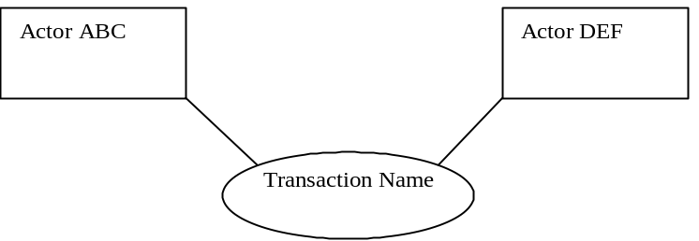

Actor:
Role:
Actor:
Role:
Actor:
Role: .

3.Y.3 Referenced Standard
<e.g., HL7 2.3.1 Chapters 2, 3>
<e.g. DICOM 2008 PS 3.3: A.35.8 X-Ray Radiation Dose SR IOD>

3.Y.4 Interaction Diagram
<the interaction diagram shows the detailed standards-based message exchange that makes up the IHE transaction>
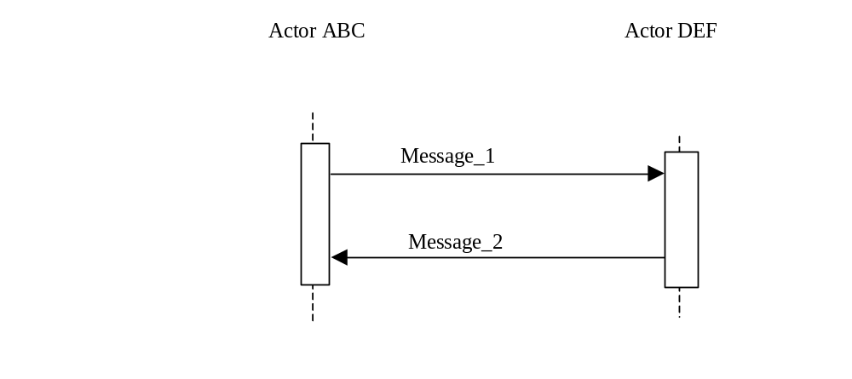
3.Y.4.1 <Message_1 Name>
<One or two sentence description of the first message of the above interaction diagram, typically relating the message to the relevant standard>

3.Y.4.1.1 Trigger Events
<description of the real world events that cause the initiation of the first message>

3.Y.4.1.2 Message Semantics
<detailed description of the meaning, structure and contents of the first message including any IHE specific clarifications of the message format, attributes, etc.>

3.Y.4.1.3 Expected Actions
<description of the actions expected to be taken as a result of sending or receiving this message>

3.Y.4.2 <Message_2 Name>
<One or two sentence description of the the next message in the above interaction diagram, typically relating the message to the relevant standard. Note, repeat this section as necessary based on the number of messages in the interaction diagram>

3.Y.4.2.1 Trigger Events
<description of the real world events that cause the initiation of the next message>

3.Y.4.2.2 Message Semantics
<detailed description of the meaning, structure and contents of the next message including any IHE specific clarifications of the message format, attributes, etc.>

3.Y.4.2.3 Expected Actions
<description of the actions expected to be taken as a result of sending or receiving this message>

3.Y.5 Security Considerations
<description of the transaction specific security consideration. Such as use of security profiles. >

3.Y.5.1 Security Audit Considerations
<This section should specifiy any specific ATNA security audit event that is associated with this transaction and requirements on the encoding of that audit event. >

3.Y.5.1.(z) Actor Specific Security Considerations
<This section should specifiy any specific security considerations on an Actor by Actor basis.>

5.0 Namespaces and Vocabularies
<This section lists the namespaces and identifiers defined or referenced by the IHE PCC Technical Framework, and the vocabularies defined or referenced therein. Additional namespaces and vocabularies shall be added to the table in the following format. For specific examples see PCC TF-2:5.0>
codeSystem | codeSystemName | Description

5.1 IHE Format Codes
<This section contains a table that lists the format codes, template identifiers and media types used by the IHE Profiles specified in the PCC Technical Framework, and also lists, for reference purposes the same values for other selected IHE Profiles from other committees. For specific examples see PCC TF-2:5.1>

Profile | Format Code | Media Type | Template ID
2010 Profiles

6.0 PCC Content Modules

6.2 Folder Content Modules

Add section 6.2.Y
6.2.Y <Folder Specification Name>
<This section corresponds to Folder Specification Y of the IHE Technical Framework. Folders are typically used to manage content profiles. This section may or may not be present depending on the issues the profile addresses.>

6.3 HL7 Version 3.0 Content Modules

6.3.1 CDA Document Content Modules

Add section 6.3.1.A
6.3.1.A <Document Content Module Specification Name>
<This section corresponds to Document Content Module Specification A of the IHE Technical Framework. This section may or may not be present depending on the issues the profile addresses.>

6.3.2 CDA Header Content Modules
Add section 6.3.2.B
6.3.2.B <Header Content Module Specification Name>
<This section corresponds to Header Content Module Specification B of the IHE Technical Framework. This section may or may not be present depending on the issues the profile addresses.>

6.3.3 CDA Section Content Modules
Add section 6.3.3.C
6.3.3.C <Section Content Module Specification Name>
<This section corresponds to Section Content Module Specification C of the IHE Technical Framework. This section may or may not be present depending on the issues the profile addresses.>

6.3.4 CDA Entry Content Modules
Add section 6.3.4.D
6.3.4.D <Entry Content Module Specification Name>
<This section corresponds to Entry Content Module Specification D of the IHE Technical Framework. This section may or may not be present depending on the issues the profile addresses.>

6.5 PCC Value Sets
Add section 6.5.A
6.5.A <Value Set Name>
<This section corresponds to Value Set A of the IHE Technical Framework. This section may or may not be present depending on the issues the profile addresses.>

<Appendix letter> Appendix_Name
<Detailed cross transaction relationships or mapping details are described in an appendix in Volume 2>

The first three documents can be located on the IHE Website at http://www.ihe.net/Technical_Framework/index.cfm#IT. The remaining documents can be obtained from their respective publishers.
AAP Guidelines for Perinatal Care. 6th Edition. P. 207

